**Key Stage 2 Art & Design – Using Sketchbooks**

**National Curriculum:**

Pupils should be taught to **develop** their **techniques**, including their **control** and their **use of materials**, with **creativity**, **experimentation** and an **increasing awareness** of different kinds of art, craft and design.

Pupils should be taught:

* to create sketch books to **record** their **observations** and use them to **review** and **revisit** ideas
* to **improve** their **mastery** of art and design **techniques**, including **drawing**, painting and sculpture with a **range of materials** [for example, pencil, charcoal, paint, clay]
* about **great artists**, **architects** and **designers** in history

**Using a sketchbook at KS2 helps pupils achieve all the national curriculum objectives above. It is the key to each child developing as an artist and designer. It is a place to:**

* Develop techniques through practice and experimentation
* Develop creatively by making connections, exploring ideas and learning from experience
* Gain an awareness of different processes through trying them out and through *failure* as much as *success*
* Record, review and revisit observations and ideas
* Improve and master techniques
* Practice drawing to gain confidence and improve control in mark-making
* Investigate, research and record findings about “great” artists and designers - allowing for both inspiration and critical thinking. Includes copying work in galleries and museums
* Collect and keep found images and ephemera for future reference
* Develop concentration skills. Drawing forces us to pay attention and to take full notice of what we are doing

**Sketchbooks are:**

**Personal** Even in a school setting, sketchbooks should be respected as a private space, over which the child has complete ownership. There should be no limits on what can be included; playfulness, experimentation and risk-taking are all to be encouraged.

Children can use sketchbooks to draw their favourite characters, copy from comics, draw from real life or from their imaginations. All are valid. It doesn’t really matter, as long as they are enjoying their exploration.

**Not right or wrong** If you are giving feedback to a child on their sketchbook work, please don’t mark it. If you want to provide written feedback, use a Post-It note. Praise should be about the child’s willingness to try things out, experiment and explore rather than the neatness, perfection or resolution of their work. The contents of a sketchbook are never right or wrong, but children should be encouraged to self-appraise and reflect on their sketches and ideas.

Note-taking should be encouraged and the sketchbook should be a space where writing doesn’t have to be in whole sentences with perfect SPAG!

**A space to work out ideas** Artists and designers use sketchbooks to plan their “finished” work. They will doodle, sketch and make notes while working out what their painting, sculpture or design will look like. Used properly, children’s sketchbooks can help them in the same way to make decisions about “final” artworks in whatever medium. Many famous paintings, sculptures, buildings and fashion designs will have taken many sketchbooks’-worth of drawings before the final piece is made. A sketchbook should be a wonderful record of the process and development of ideas – it’s a journal of the creative process.

**Ideal companions for any trips, visits or special experiences** Every visit you go on with your class should include sketchbooks. Children can record what they see, make notes on what they experience, collect tickets, do rubbings – the possibilities are endless. They should not just be used for “art” but become a habit that will help children take ownership of their learning and experiences and have a record to share with peers, families and teachers.

**For teachers too!** When you embark on using sketchbooks with your class, why not get one for yourself too? Use it whenever you ask the children to use theirs. Don’t be afraid to model mark-making and experimentation – this will help the children. If you say “I can’t draw” children will learn that this is acceptable. It’s not: if you can hold a pencil and make a mark you can draw! Arranging those marks in ways that are pleasing to you is something you can get better at – but only through practice…Don’t judge yourself too harshly and enjoy playing with marks and ideas.

**Great for homework tasks** Although the sketchbook needs to be a personal space, you can also set exciting and challenging tasks for children to do as homeworks, in class, in after-school clubs or rainy playtimes. These can relate to any subject, topic or curriculum area, or be purely for fun. See attached a list of ideas for sketchbook challenges.

**Something to share** Once your class has got up and running with their sketchbooks, they are great for sharing and discussion. Children could elect to share something new they have tried, an experiment they are proud of, something they found hard or a task they enjoyed in their sketchbooks. Small groups or talking pairs can peer review or children can talk about their sketchbook journeys in assemblies.

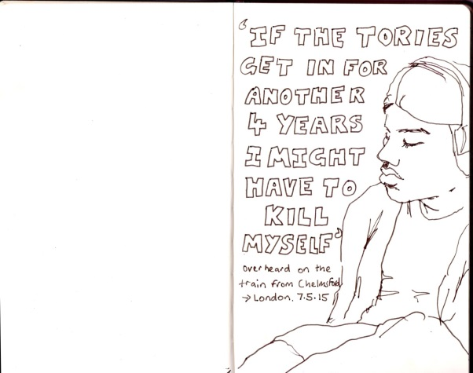 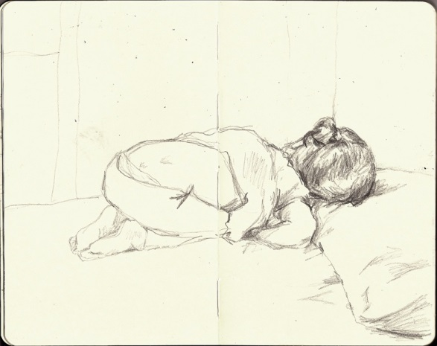

Observational drawings

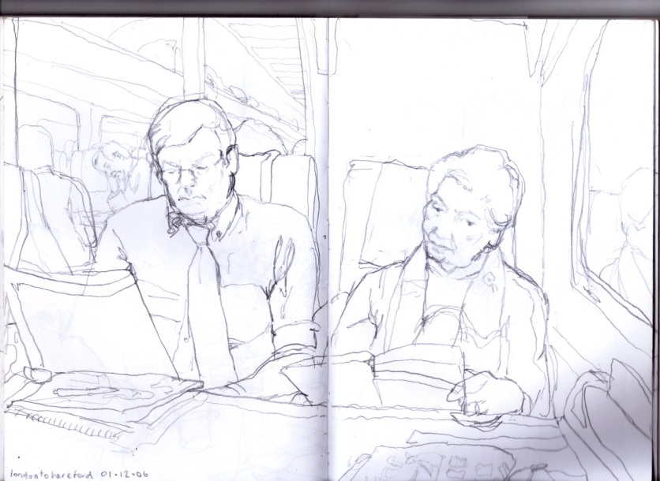 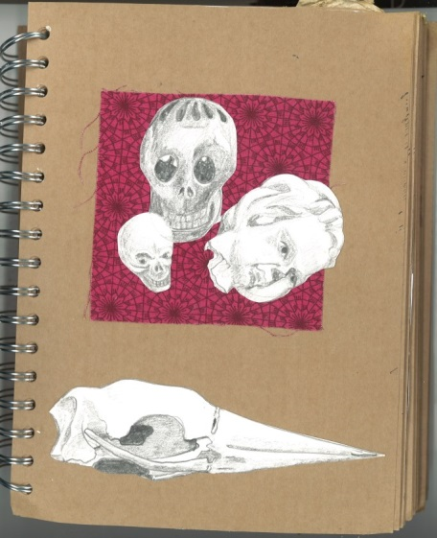

Observational drawing & cut-out observational drawing with mixed media collage

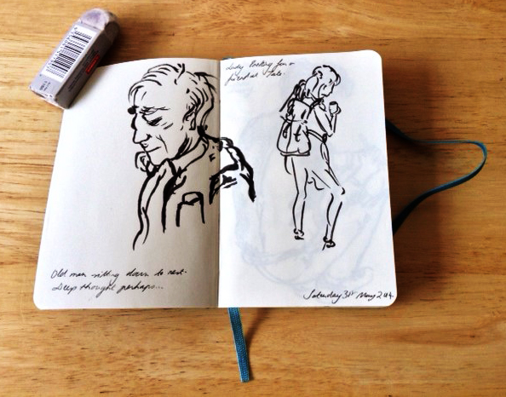 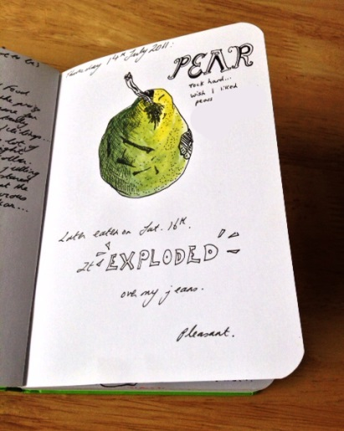

Observational drawing & recording a moment

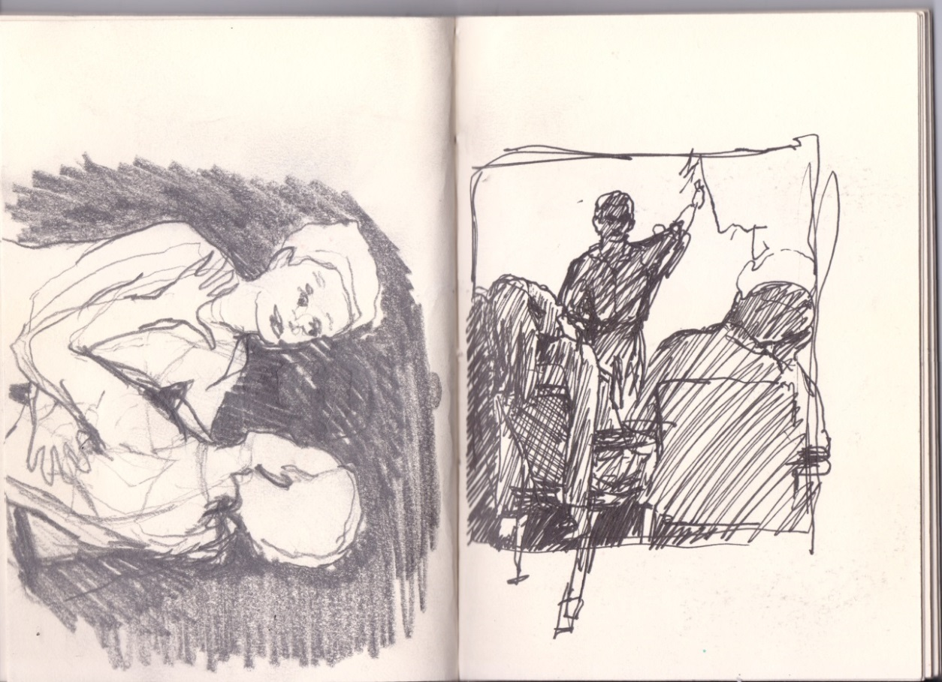

Sketches for an illustration commission

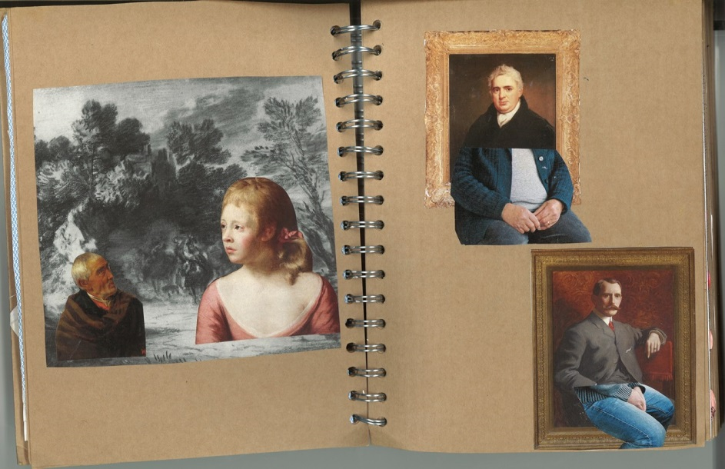

Collage using magazines and art catalogues

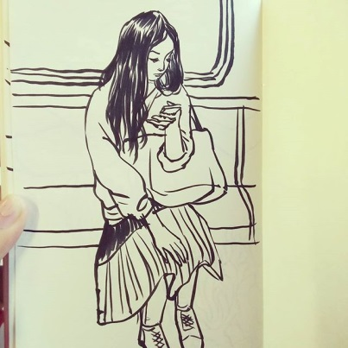 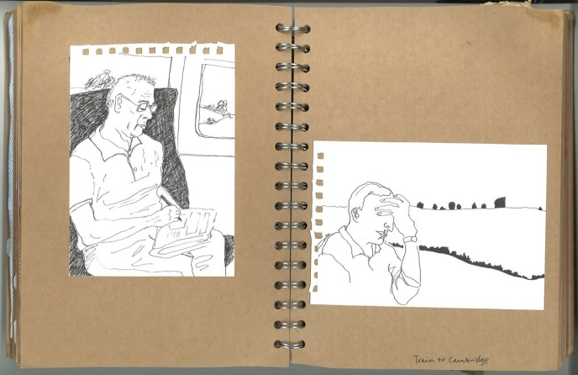

Observational drawings

**Sketchbook challenges**

**Observation**

* Draw a member of your family watching TV or playing a game. Try and include the chair they are sitting in and other parts of the surroundings.
* Draw your dinner.
* Choose a letter of the alphabet and every time you see something beginning with that letter draw it. Fill a page with small, quick drawings and do this for a whole day.
* Get a postcard of a work of art, a page from a comic or a book cover and copy it in your sketchbook.
* Try this again, but turn the postcard upside-down first. Compare the two drawings (it is likely the second will be much better than the first!).
* Do a self portrait without looking at the paper – just in the mirror.
* Imagine you need to explain to an alien who can’t read English how to do something simple like make a cup of tea. Draw 4 boxes on a page in your sketchbook and draw the step-by-step instructions for the alien to follow.
* Draw the view out of each window in your home.

**Imagination**

* Draw what you dreamt last night.
* Draw a character from a book you’re reading.
* Draw the next scene in a book, film or TV programme that you like.
* From memory, draw all the presents you got on your last birthday.
* Listen to some music and draw the shapes and colours you see in your mind when you listen.
* Draw an object you own from memory (no peeking at the object when you do this) then draw it from observation and compare the results.
* Draw yourself as an animal
* Draw a scene of your two favourite characters from different books (or films), what would they be doing?

**Experimenting with different materials**

* Find scraps of paper like old envelopes and stick these in your sketchbook to create a more interesting background to draw on.
* Cut out a random image from a magazine and stick it on a page. Draw to make the image into something totally different.
* Use crayons to do rubbings of different textures you find on your way home from school eg. tree bark, pavement, manhole covers etc.
* With collage the possibilities are endless. Collect interesting papers and pages from magazines. Select a theme or topic and create new pictures using a variety of collaged images. When using photos, it is worth cutting these out carefully to make really interesting new images.
* Using a variety of pencils, pens, crayons etc. make as many different types of line as you can on one page.
* Collect as many different types of font as you can from newspapers, magazines and packaging. Copy ones that you like and try inventing your own going through each letter of the alphabet and trying different things out. Draw your name out in your favourite.
* Draw something you've drawn before (observational or imagination) but with a completely different material

**Resources – where to get sketchbooks and specialist art materials**

The best place to get inexpensive high quality sketchbooks for school use is Seawhite: <http://www.seawhite.co.uk/online/>

Good art suppliers include:

Cass Art (nearest branch Islington) <https://www.cassart.co.uk/>

Specialist Crafts <http://www.specialistcrafts.co.uk/>

London Graphic Centre <http://www.londongraphics.co.uk/>

**Resources – books and online examples of sketchbooks**

Drawn In by Julia Rothman <http://www.juliarothman.com/drawn-in/#1>

Drawing Projects for Children by Paula Briggs <https://www.accessart.org.uk/drawing-projects-children-paula-briggs/>

Access Art – membership organisation for schools with resources and access to artists <http://www.accessart.org.uk/>

Instagram: #tatesketchbook

Sketchbook Circle for art educators <http://www.sketchbookcircle.com/>