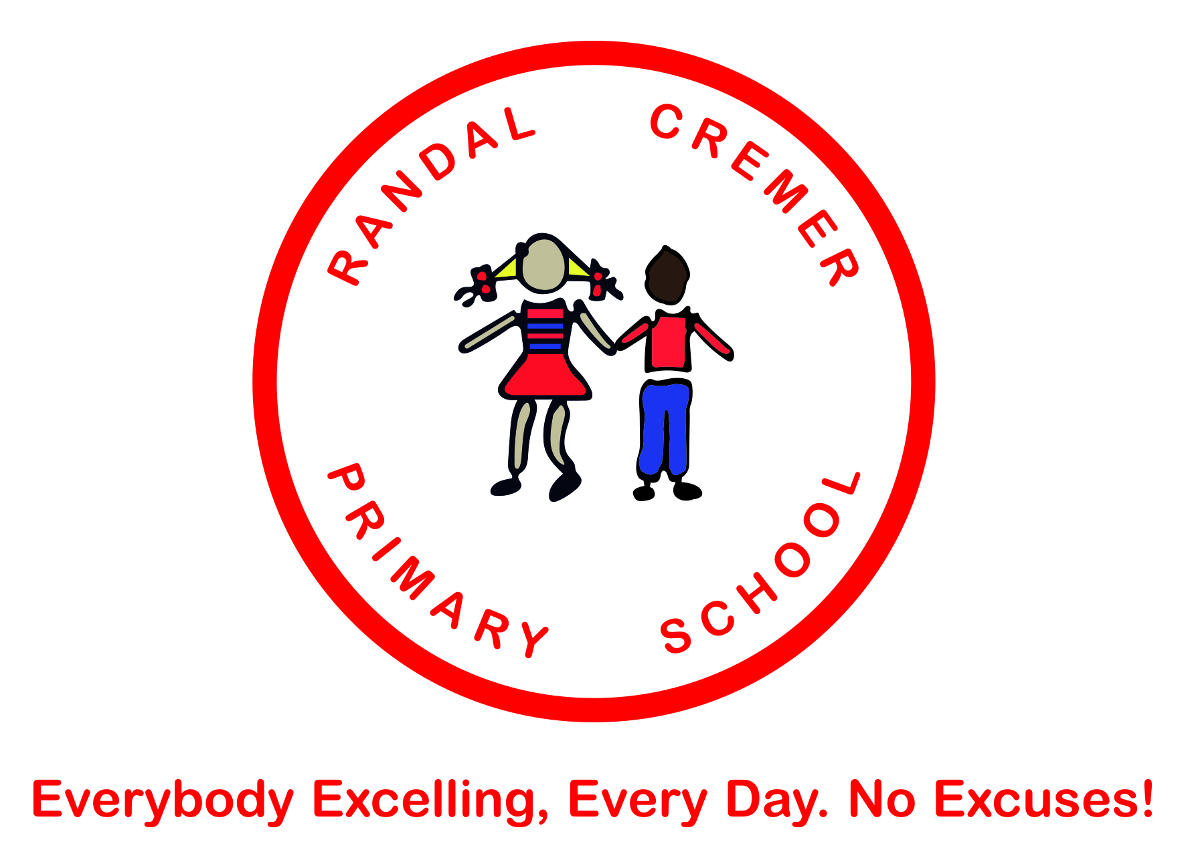

Policy for EYFS

Date: February 2017
Review Date: February 2019
Ratified by Governing Body
Signed
Chair of Governors.

Vision

Every Pupil will leave Randal Cremer able to excel academically and socially.

Values
Respect

All Members of our School Community are important to the success of Randal Cremer Primary School

We respect that everyone matters - everyone feels that they are treated fairly & listened to in a non-judgemental manner

We recognise that everyone has a right to the highest possible standard of education and that we each have a personal responsibility to ourselves and others to ensure that this right is never compromised.

Diversity, Inclusion & Equality

We put diversity, inclusion and equality at the heart of everything we do

We welcome and accept all people, and ensure we understand & celebrate everyone’s unique differences and similarities

Love

We provide a caring, compassionate, warm, welcoming and nurturing environment for all members of our School Community

Teamwork

We value our relationships and work hard with all members of our School Community to achieve the School’s Vision.

High Expectations

We have a commitment to ensure outstanding achievement, enjoyment, health & happiness for self & all members of our School Community

We recognise it takes a ‘village’ to educate a child

We all work together to ensure consistency of outstanding processes & practices

Early Years Foundation Stage Policy
Introduction
This document is a description of our current practice and procedures in the teaching of the Early Years Foundation Stage. The characteristics of effective learning are the ways in which a child engages with other people and their environment – playing and exploring, active learning, and creating and thinking critically – underpin learning and development across all areas and support a child to remain an effective and motivated learner.
The prime areas begin to develop quickly in response to relationships and experiences, and run through and support learning in all other areas. The prime areas continue to be fundamental throughout the EYFS.
Prime areas are fundamental, work together, and move through to support development in all other areas.
Personal, Social and Emotional Development | Communication and Language
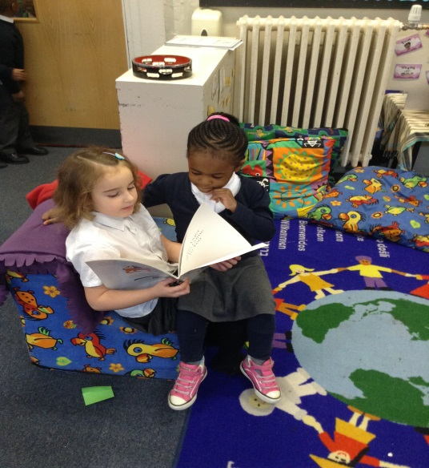 | 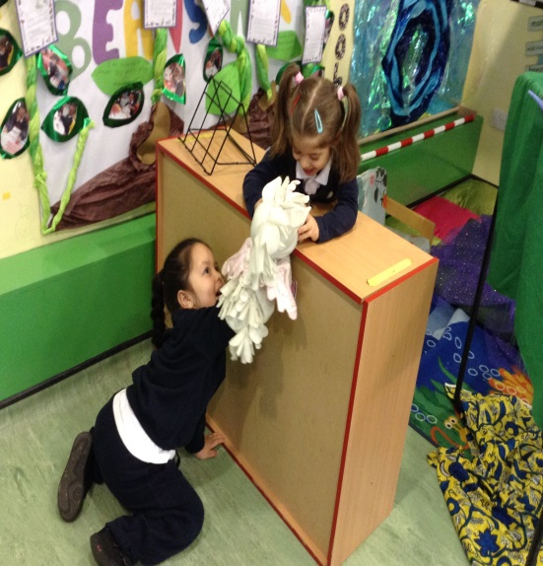
Physical Development
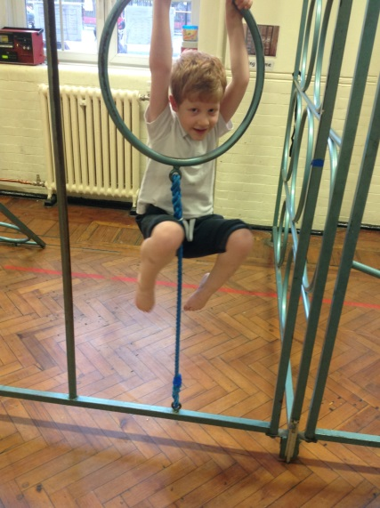

The specific areas include essential skills and knowledge. They grow out of the prime areas, and provide important contexts for learning. Specific areas include essential skills and knowledge for children to participate successfully in society.
Literacy  Reading  Writing  Daily phonics included. | 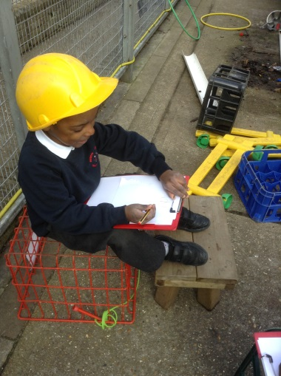
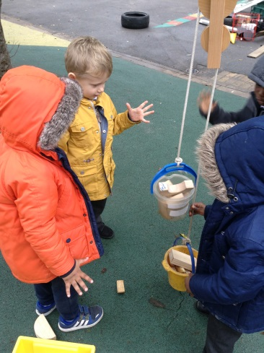 | Mathematics
Understanding the World | 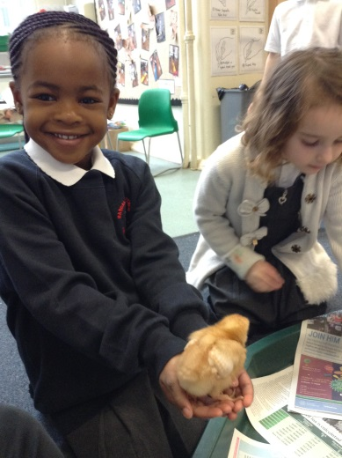
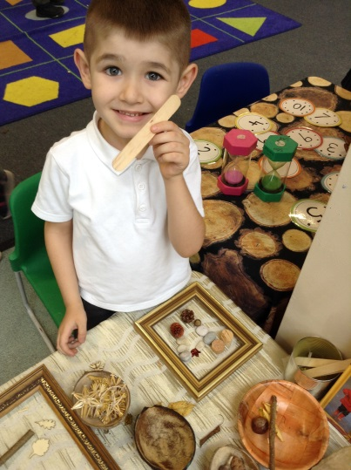 | Expressive Arts & Design

It also refers to our practice of cross curricular teaching and learning which encourages children to make links and practise skills in a relevant and interesting way.
Our belief is that all individual learning styles should be recognised and honoured in a creative learning environment. The way in which we learn is as important to progress and success as what we learn.
The following policy reflects the consensus of opinion of the teaching staff and has the support of the governing body. It is updated by means of annual review, when aims are set for the following year.
Subject Philosophy
Every child deserves the best possible start in life and support to fulfill their potential. A child’s experience in the early years has a major impact on their future life chances. A secure, safe and happy childhood is important in its own right, and it provides the foundation for children to make the most of their abilities and talents as they grow up.
The overarching aim of the EYFS is to help young children achieve the five Every Child Matters outcomes of staying safe, being healthy, enjoying and achieving, making a positive contribution, and achieving economic well-being by:
- setting the standards for the learning, development and care young children should experience when they are attending a setting outside their family home, ensuring that every child makes progress and that no child gets left behind;
- providing for equality of opportunity and anti-discriminatory practice and ensuring that every child is included and not disadvantaged because of ethnicity, culture or religion, home language, family background, learning difficulties or disabilities, gender or ability;
- creating the framework for partnership working between parents and professionals, and between all the settings that the child attends;
- improving quality and consistency in the early years sector through a universal set of standards which apply to all settings, ending the distinction between care and learning in the existing frameworks, and providing the basis for the inspection and regulation regime;
- laying a secure foundation for future learning through learning and development that is planned around the individual needs and interests of the child, and informed by the use of ongoing observational assessment.

The EYFS principles which guide the work of all practitioners are grouped into four distinct but complementary themes:
- A Unique Child
- Positive Relationships
- Enabling Environments
- Learning and Development

Entitlement
Teaching and learning of all subject areas begins in the Foundations Stage and has its basis in play and discovery.
Every child, regardless of ability, experience and background will be supported to be successful within this area of learning. Those children identified as requiring extra assistance are afforded opportunities through time spent with staff members as well as the support entitlement of their Individual Education Programmes.
Curricular Delivery
The learning and teaching of the different curriculum areas within the Early Years Foundation Stage within the timetable varies according to the interests and needs of the children. In the Foundation Stage, much of the learning takes place through play which is important for children’s all round physical, emotional, intellectual and social development. Links are made to the seven areas of learning in the Early Years Foundation Stage Framework.
Our school has 5 core values that underpin are practice from Nursery to Year 6:
- Love
- Respect
- Teamwork
- High Expectations
- Equality, Diversity and Inclusion

Play  We know that play is the basis of learning and fundamental to the healthy development and well-being of individuals. Although we ensure that our children are able to determine for themselves the content and intent of their play, it is underpinned by our knowledge of each child. By ensuring the provision we make for them is challenging, language rich, and underpinned by the development of physical and social skills needed to be successful learners and members of a community we ensure that our children are ready for the next stage in their learning. | 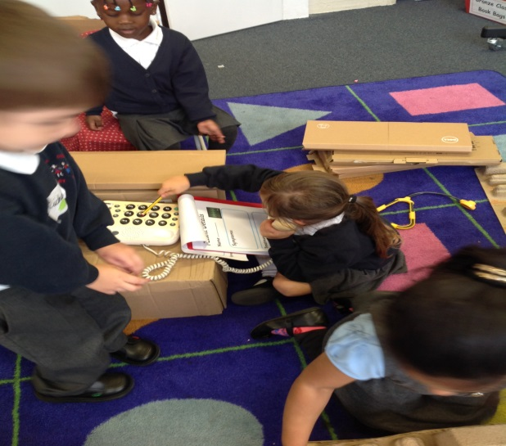
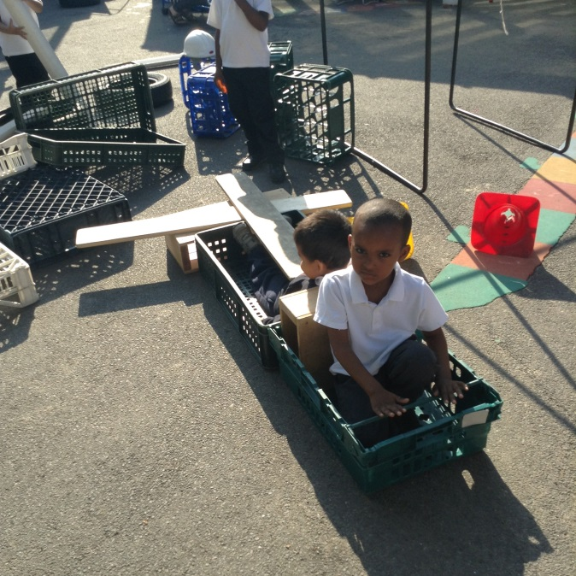 | Outdoor Learning including Forest School  We believe strongly that there is an inherent risk associated with learning and our whole school approach to developing a Growth Mindset is part of this. Learning is going from what is known and familiar to what is unknown and uncertain and it is through the outdoor environment that our children can really get to grips with the unpredictable, engaging and challenging world around them. Our children are expected to access the outdoors in all weathers and appropriate protective clothing is supplied.
Physical Literacy  We recognise that for children to be successful in their learning, they need to develop coordination of body and brain in which their muscles encounter resistance: pushing, pulling, stretching and carrying. We know that a focus on movement actually enables our children to sit still, grasp a pencil, focus their attention, so in EYFS we ensure that children are given many opportunities to develop their core physical skills. A specialist in children’s physical development has worked closely with the EYFS team to develop an environment and approach to learning both indoor and outdoor that promotes physical development. | 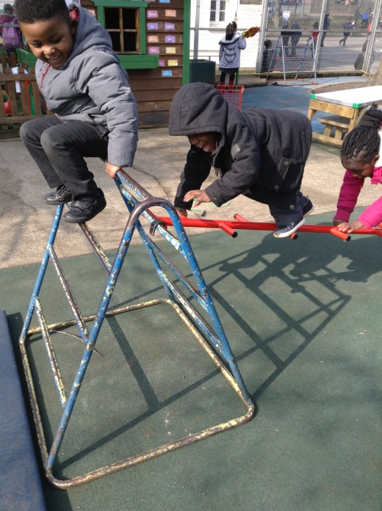
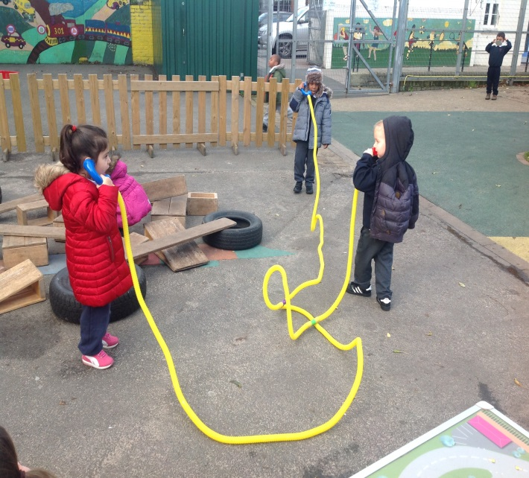 | Communication and Language  At Randal Cremer, the importance of language development is central to our practice. From Nursery we ensure children are exposed to a rich language environment. We also recognise listening as a important part of communication and ensure that children are able to ‘hear and understand’ as well as talk and be heard. Led by a Specialist Speech and Language Therapist, we ensure that all children entering our setting are screened so that children with language delay can receive appropriate intervention whilst ensuring that specific language concepts are taught.

Resources
The quality of resources offered to our children, as a vehicle for their learning, is seen as crucial to the overall success of learning and teaching within the school. We focus on ensuring that the continuous provision engages children in high level learning. We ensure that children are able to choose for themselves which resources to access but we also carefully plan activities and learning opportunities that inspire children and engages their natural curiosity.
Health and Safety
Class teachers will carry out individual risk assessment based on activities, substances or equipment used. These will take into account age of children and level of supervision and will identify measures to reduce risk.
Assessment, Recording and Reporting
The most important and productive assessment is the on-going, formative teacher assessment of learning made by staff during their daily teaching. Evaluation and review of practice and outcomes are made and inform planning. Learning outcomes are shared and immediate feedback and next steps for the children can be discussed. Peer and self-assessment occurs daily as children work together. All children have a learning journey for observational assessments which are made during Child Initiated Learning opportunities as well as some focused tasks. These are shared regularly with parents and parents also have their own to share with school. Assessments in Nursery and Reception are made using Development Matters and tracked using Learning Journeys and School Pupil Tracker. The final Foundation Stage assessments are made in the Summer Term against the Early Learning Goals and moderated internally as well as with support from the LA.
Monitoring
Teaching and learning, curriculum coverage and standards are monitored by members of the curricular group. Evidence is collected and monitored e.g. photographs, planning, lesson observations, book scrutiny where applicable and examples of work/outcomes.
Special Needs/Inclusion
Every child in the school has access to their full entitlement as outlined in the Schemes of Work. Where required, an amanuensis or scribe is provided so that the child has full access to the curriculum and can be assessed appropriately.
Differentiation extends to planning and preparation for individual children as deemed appropriate. This includes more able children.
A Partnership between Home and School
We recognise that learning begins at home and therefore we value the contributions of parents in teaching and learning. Parents are informed on a half-termly basis of the topics covered, and encouraged to support the school’s homework policy. Parents are invited into school each week to participate in Reading mornings in addition to themed days and educational visits.
We also deliver weekly workshops to parents about subjects they identify. These range from developing language to supporting behaviour.
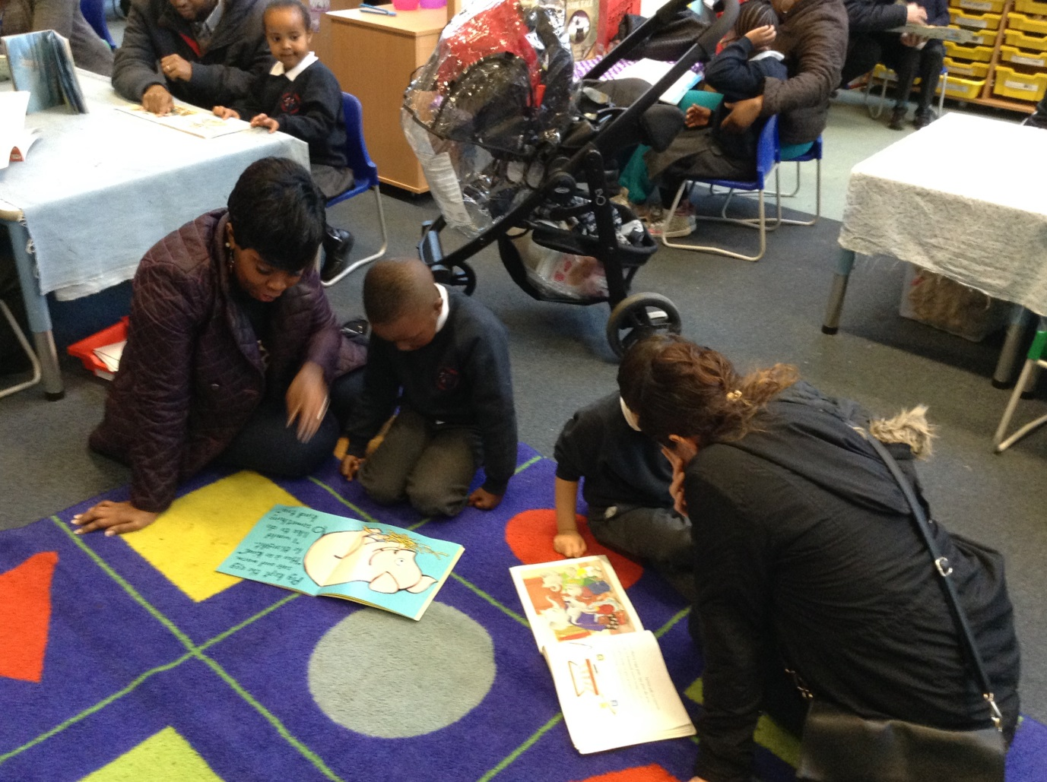
Equal Opportunities
We monitor both the delivery and coverage of the curriculum to ensure that all children have equal access. We attend to, and acknowledge differences positively. Our belief in individualised, differentiated teaching pays regard to gender, culture, ethnicity, children who speak additional languages and those who are differently able. Resources are chosen and monitored in relation not only to quality, but also to the positive representation of gender and cultural differences

