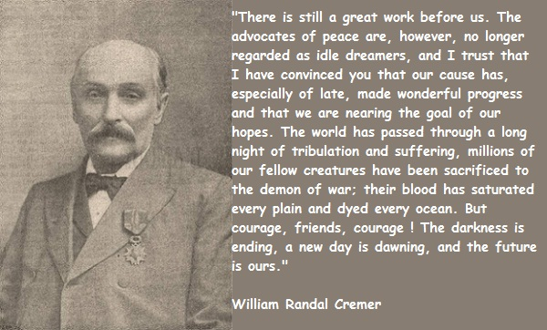
Randal Cremer Peace Prize 2016
Nominations for the Randal Cremer Peace Prize are now open.
Is there someone in your class who demonstrates the peace keeping skills that helped Randal Cremer become the first British person to win the Nobel Peace Prize?
Are they good listeners?
Are they fair minded?
Do they notice when someone is unhappy and do something about it?
Do they encourage children to talk through problems to try and resolve the problem themselves?
You can nominate someone by picking up the form from Leanne in Jo’s office.
Closing date for nominations; Friday 8th July 2016.

